SSIP 2.0 Awareness Seminar

Date: - 26th May,2023
The seminar on awareness of student startup and innovation policy was held with the aim of educating and empowering students about the policies and opportunities available to them in the field of entrepreneurship and innovation. The event brought together for students and educators to foster a culture of innovation and encourage students to pursue their entrepreneurial dreams.
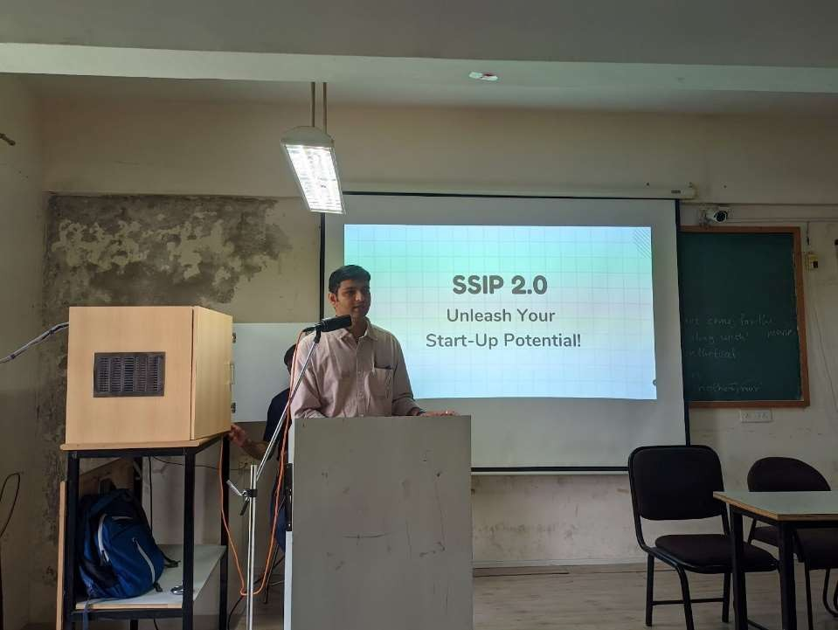

The main objective of the seminar was,
- To create awareness about the student startup and innovation policy (SSIP 2.0).
- To educate students about the benefits and opportunities available in the field of entrepreneurship.
- To inspire and motivate students to explore their innovative ideas and turn them into successful startups.
- To provide insights into the support systems, funding options, and resources available for student startups.

The seminar began with opening remarks by the event organizer “Prof. Kuntesh Jani”- co-ordinator of SSIP
2.0 Of IT department, highlighting the significance of fostering an entrepreneurial mindset among students and the importance of the student startup and innovation policy. They shared their own experiences and success stories to motivate and inspire the students. The event was held in offline mode and more than 150 students were benefited from this insightful session. More than 5 Faculties were also present.

Initially there was an Overview on Student Startup and Innovation Policy. In which, a representative from the SSIP Student Team and relevant authority presented an overview of the SSIP 2.0 policy. The presentation covered the objectives, benefits, and provisions of the policy, emphasizing how it supports and encourages student startups. Then there was a Success Stories session. In which, Students who had previously registered successful startup ideas with SSIP shared their journey, challenges faced, and lessons learned. This session aimed to inspire students by showcasing real-world examples of student entrepreneurship. Additionally, Resources and Support Systems: Representatives from Prarambh Cell which is basically a student community to help SSIP enthusiasts, provided information about the resources, mentorship, funding opportunities, and other support available for students. Finally, the seminar concluded with an interactive Q&A session, allowing students to seek clarifications and further guidance from the experts.

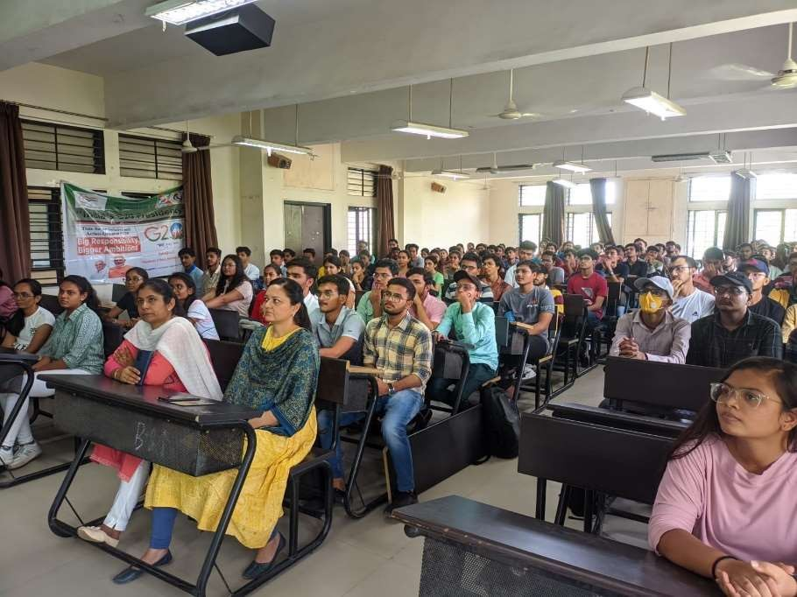

The seminar on awareness of SSIP proved to be an informative and inspiring event. It provided students with valuable insights, resources, and guidance to pursue their entrepreneurial aspirations. By fostering an entrepreneurial culture, the seminar aimed to contribute to the growth of innovative startups and create a conducive environment for student entrepreneurs.

